1. 產生公鑰

SourceTree>Tools>Create or Import SSH Keys

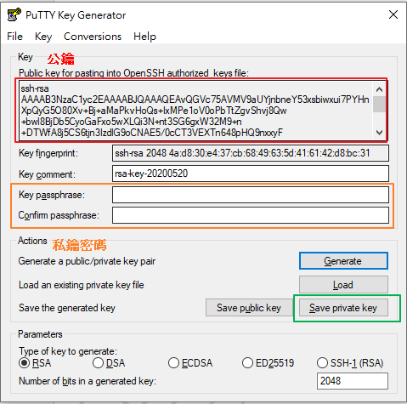

2.產出後至版控工具設定畫面新增SSH Key(Public Key)

BitBucket

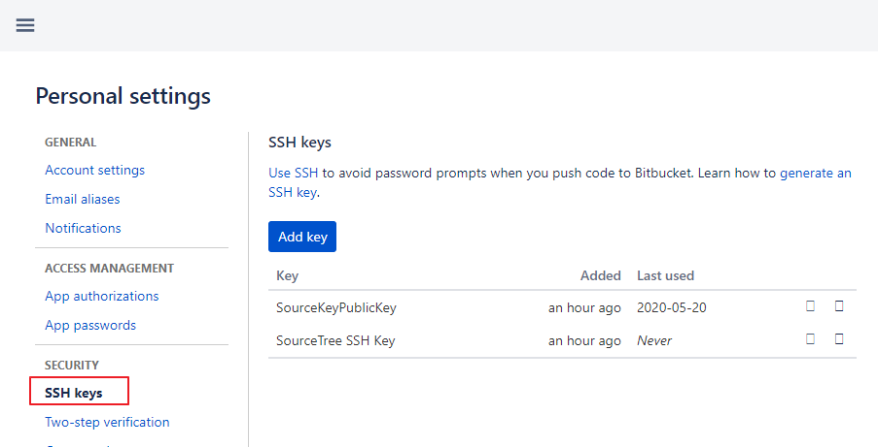

3. 再本機新增private key(右鍵>Add Key>選擇private key檔案路徑)

